**Unit l How Tall Are You?**

**Part B(第一课时)**

I．看图，仿照例句填空。

[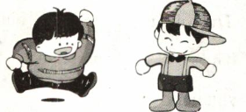](http://www.zzstep.com/)[来源:中国%*教育~^出@版网]

例子：heavy——heavier——I’m heavierthan you．

[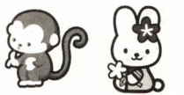](http://www.zzstep.com/)

1．1ong——longer—— ．[w^ww.z&zste@%p.com*]

[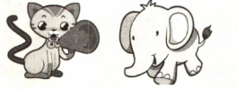](http://www.zzstep.com/)

2．big—— ——I'm bigger than you．

Ⅱ．单项选择。

( )1．一 are your feet? 一1 wear size l7．

A．How long B．How big C．How tall

( )2．My legs are than Mike’s．

A．1onger B．taller C．small

( )3．一How is your father?--He’s 50 kg．

A．tall B．old C．heavy

( )4．一 are you?一I am ten years old．

A．How tall B．How far C．HOW old[ww&~w@.zzstep.#c^om]

( )5．My arms are than yours．

A．taller B．shorter C．1ong

Ⅲ．补全对话。

1.Dad：

Tom：I like the yellow monkey．

2．Mary：

Lucy：I am strong．I am 75 kg．

1. Mike：

Lucy：I am l5 years old．

4．Tom：

Jim：I am l50 cm tall．

Ⅳ．按要求完成下列各题。[来@源:z%zstep.&^co*m]

1．I am l50 cm tall．(就画线部分提问)

2. My hands are smaller than yours．(改为同义句)

3．I am ten years old．He is five years old．(用比较级合为一句)[www.z*~zst^%ep@.com]

4．I like the white monkey．(就画线部分提问)

[中#国~教育@*出%版网]

5．My legs are 50 cm long．(就画线部分提问)

V．学习直通车。[来源~&:中教^@%网]

形容词比较等级的不规则变化

|  |  |  |
| --- | --- | --- |
| 原级 | 比较级 | 最高级 |
| good/well | better | best |
| bad/ill | worse | worst |
| many/much | more | most |
| little | less | least |
| far | farther较远的 further进一步的 | farthest furthest |
| old | older较老的 elder较年长的 | oldest eldest |

**参考答案[www.zz&^s#tep.co*m~]**

I. 1. My tail is longer than yours. 2. bigger[w&@w^w.%zzst~ep.com]

II.1. B 2.A 3.C 4.C 5.B

III. 1. Which monkey do you like?[来#~&*源:中教^网]

2. How heavy are you?

3. How old are you?

4. How tall are you?

IV. 1. How tall are you?

2. Your hands are bigger than mine,

3. I am five years older than him,/He is five years younger than me.

4. Which monkey do you like?

6. How long are your legs?